

Name : Muhammad Ammanullah

Sap I`d : 55633

Name : Ruman Bashir

Sap I`d : 38741

Section : BS SE ( 5 – 2 )

Course : Software Construction & Development

Class Diagram :
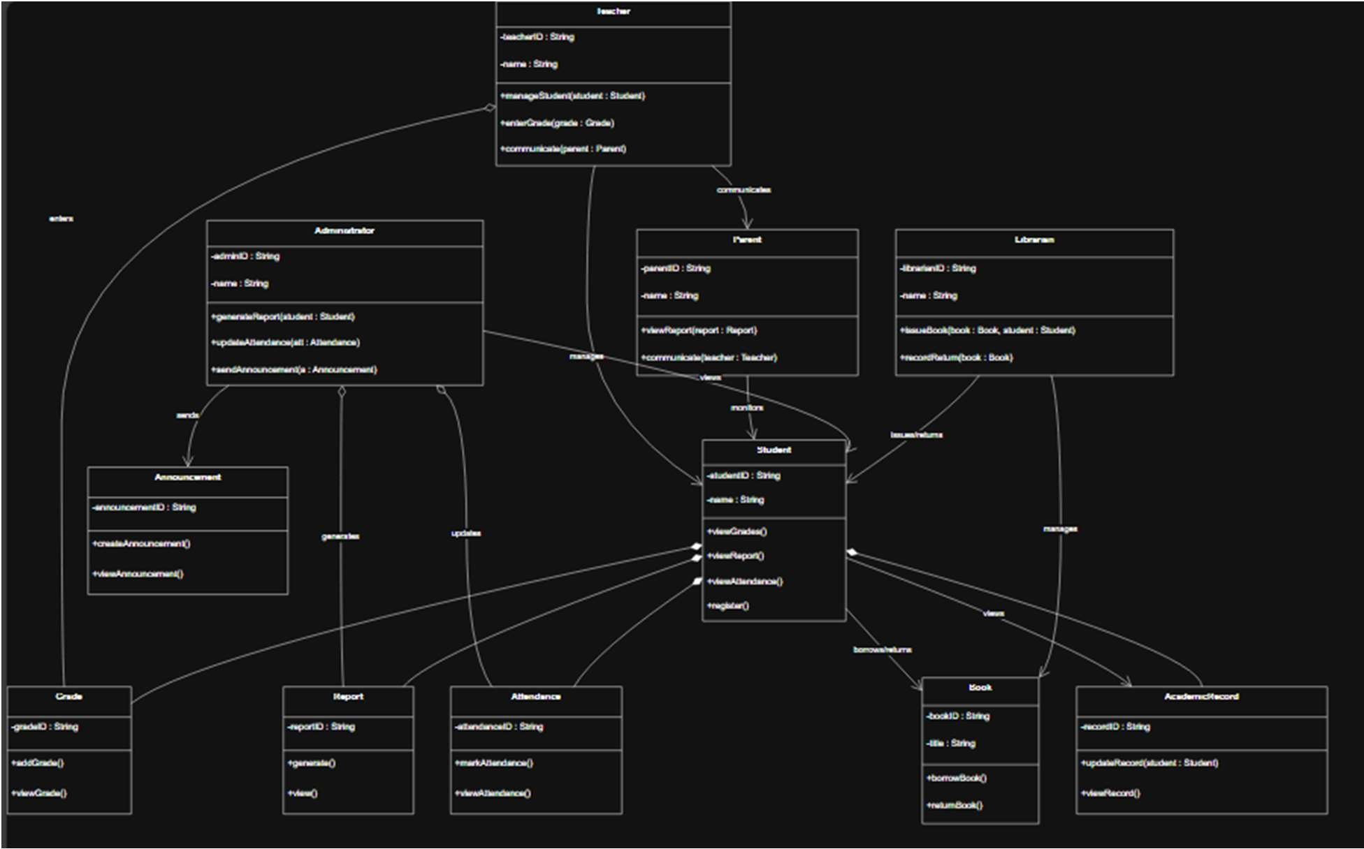
Activity Diagram :
1. Student View Academic Records
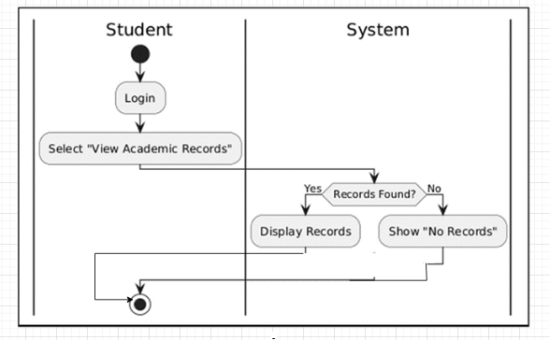

Student – View Grades
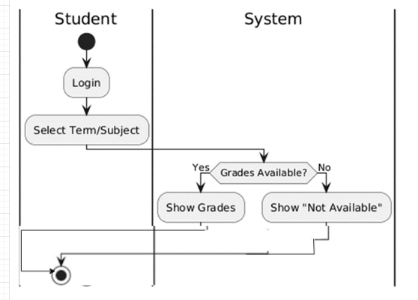

Student – View Attendance
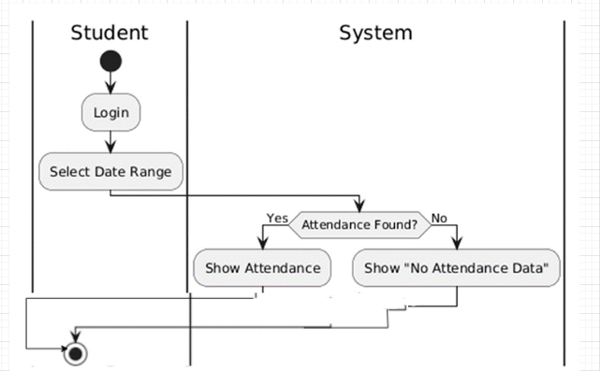

Student – Communicate With Teacher

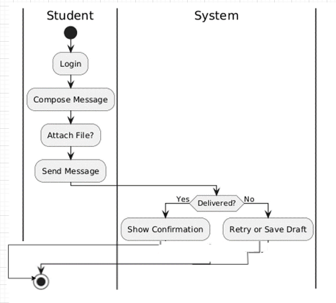

Student – Receive Announcements

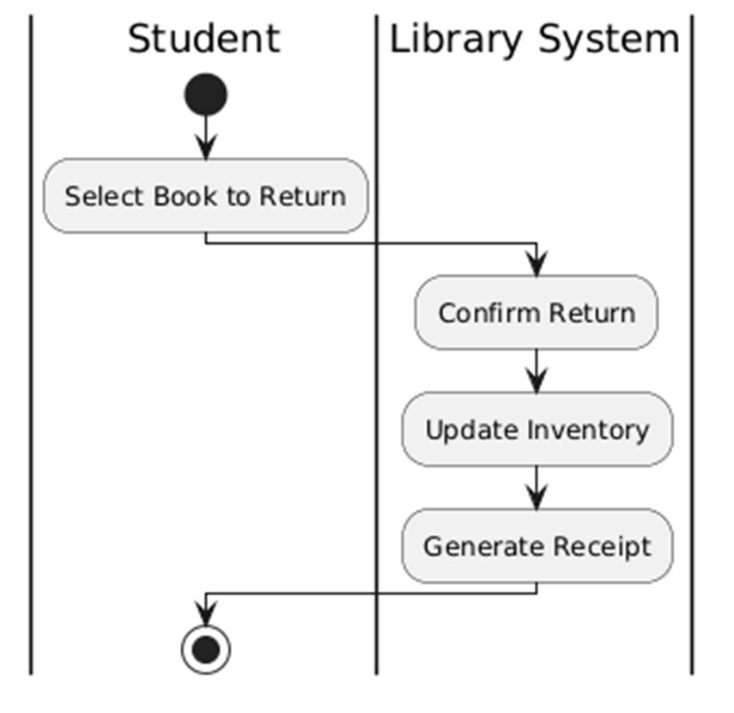

Student – Issue Books
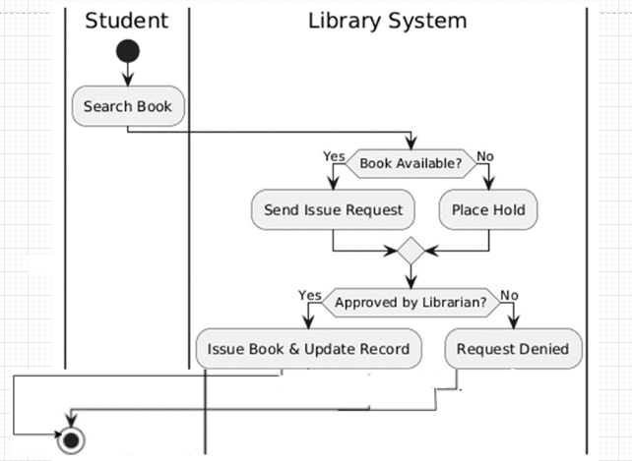

Student – Return Books

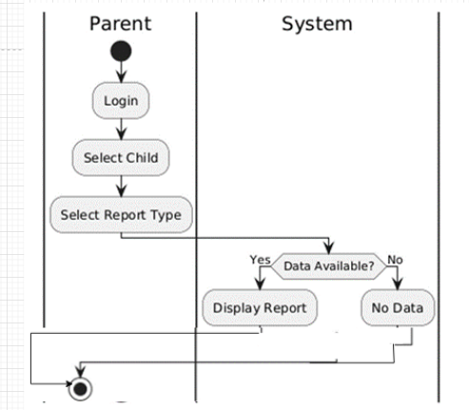

Parent – View Child Performance

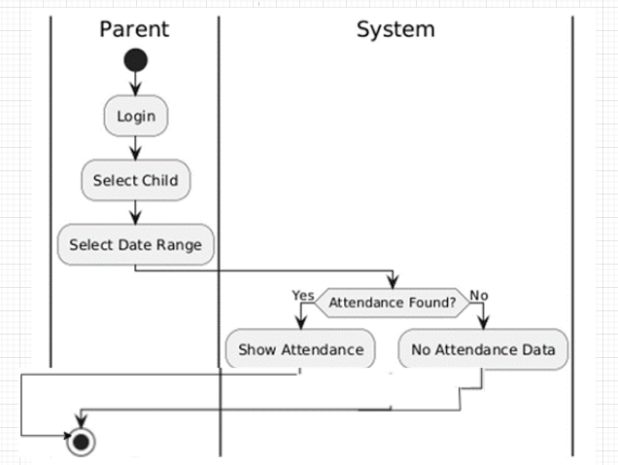
Parent – View Attendance

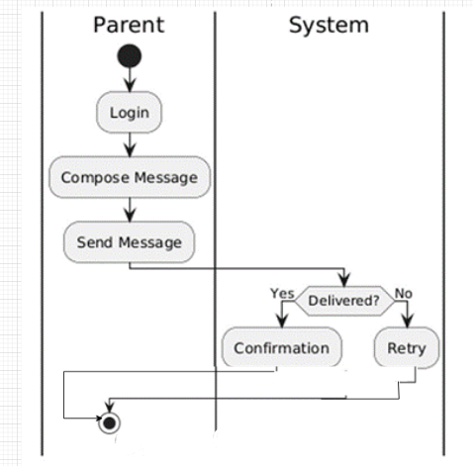

Parent – Communicate with Teacher
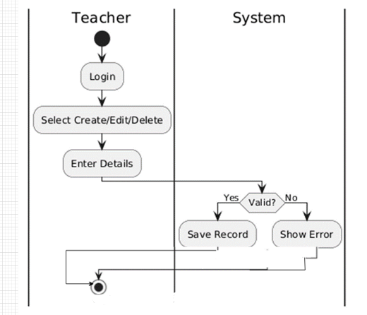

Teacher – Manage Student Profiles

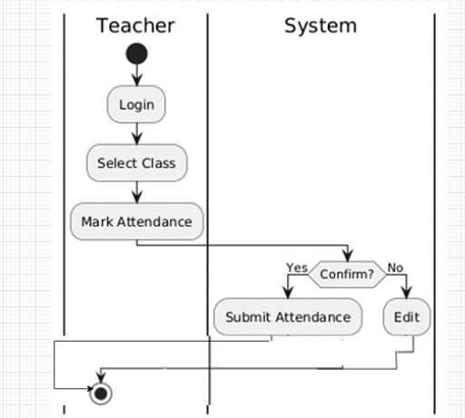

Teacher – Record Attendance
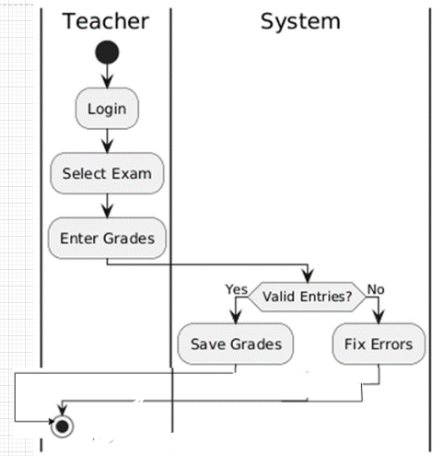

Teacher – Enter Grades
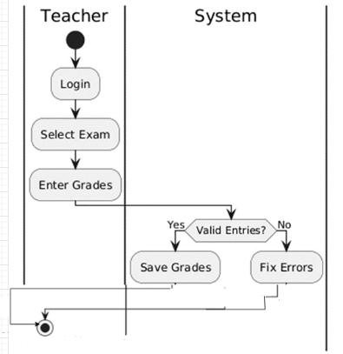

Admin – Register Student

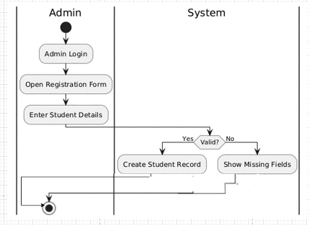

Admin – Generate Reports

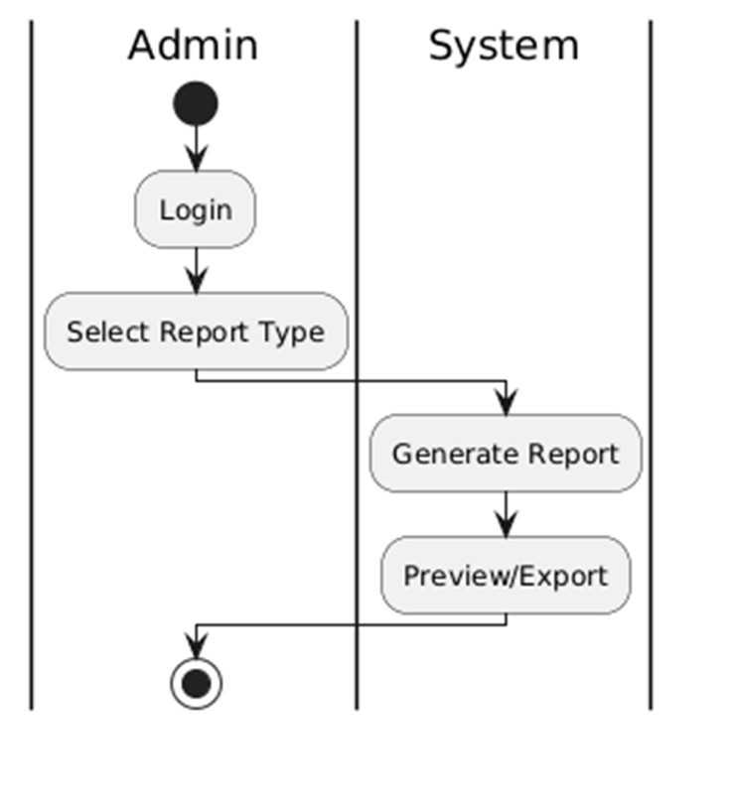

Librarian – Manage Books

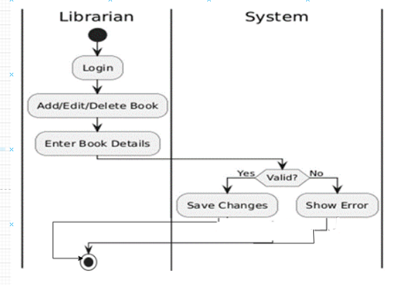

Librarian – Issue Books

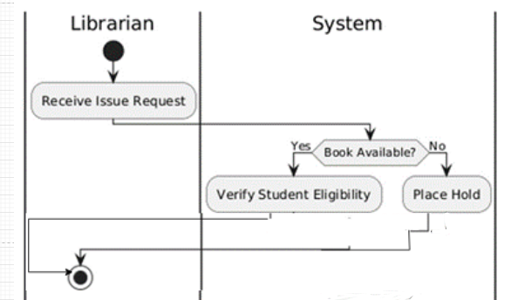

Librarian – Return Books
